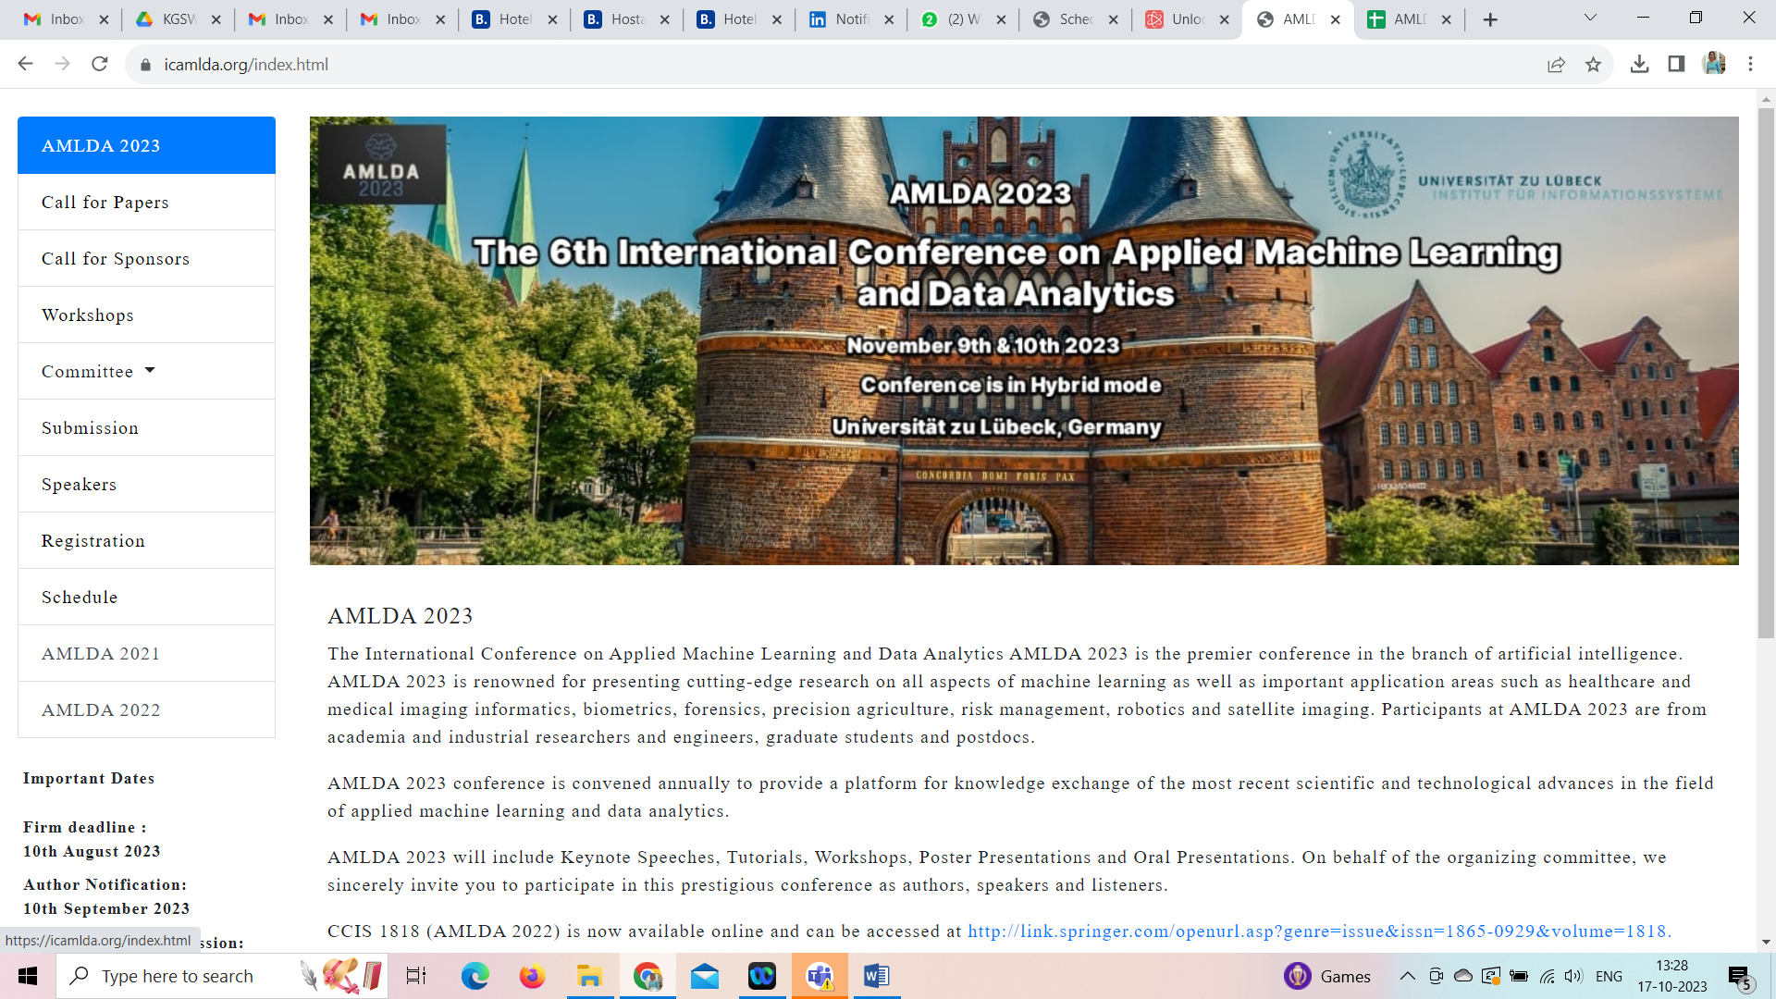



**Applied Machine Learning Analytics Conference 2023**

**09–10 November 2023**

**November 09, 2023**

**9:00 am – 3:00 pm**

**Central European Time (Lubeck, Germany)**

|  |  |  |  |
| --- | --- | --- | --- |
| **Date: 09/11/2023 Day: Thursday** | | | |
| **S. No** | **Time** | **Paper ID** | **Paper Session 1 (Titles)** |
| 1. | 9:00 – 9:15 | 2 | Process Selection for RPA Projects with MDCM: The Case of Izmir Bakircay University |
| 2. | 9:15 – 9:30 | 7 | Algorithmic decision making in government: Reflections for intelligent planning and systems improvement |
| 3. | 9:30 – 9:45 | 12 | A Secure and Transparent Solution to Detect Counterfeit Products |
| 4. | 9:45 – 10:00 | 22 | Forecasting User Payment Behavior using Machine Learning |
| 5. | 10:00 – 10:15 | 23 | An Efficient Image Dehazing Technique using DSRGAN & VGG19 |
| 6. | 10:15 – 10:30 | 30 | Benchmarking ML and DL Models for Mango Leaf Disease Detection: A Comparative Analysis |
| **10:30 – 11:00 Break** | | | |
| **S. No** | **Time** | **Paper ID** | **Paper Session 2 (Titles)** |
| 1. | 11:00 – 11:15 | 35 | Cassava Syndrome Scan a Pioneering Deep Learning System for Accurate Cassava Leaf Disease Classification |
| 2. | 11:15 – 11:30 | 40 | Aspect-Based Sentiment Classification of Online Product Reviews Using Hybrid Lexicon-Machine Learning Approach |
| 3. | 11:30 – 11:45 | 44 | DESI: Diversification of E-commerce recommendations using Semantic Intelligence |
| 4. | 11:45 – 12:00 | 46 | Adaptive Neuro Fuzzy-Based Depression Detection Model for Students in Tertiary Education |
| 5. | 12:00 – 12:15 | 55 | Optimizing Portfolio for Highly Funded Industries within Budget Constraints for the Period of 2023-2024 |
| 6. | 12:15 – 12:30 | 64 | AI Insights: Unleashing Financial Distress Signals |
| **12:30 – 14:00 Lunch Break** | | | |
| **S. No** | **Time** | **Paper ID** | **Paper Session 3 (Titles)** |
| 1. | 14:00 – 14:15 | 65 | EventHive: Your Smart and Personal Event Concierge - Seamless Management and Tailored Recommendations |
| 2. | 14:15 – 14:30 | 66 | Intensity-Chromaticity-Luminance (ICL) based Technique for Face Spoofing Detection |
| 3. | 14:30 – 14:45 | 71 | Sentiment Analysis of Monkeypox Tweets in Latin America |
| 4. | 14:45 – 15:00 | 72 | Stock Market Prediction with Artificial Intelligence Techniques in Recession Times |

|  |  |  |  |  |
| --- | --- | --- | --- | --- |
| **Date: 10/11/2023 Day: Friday** | | | | |
| **S. No** | **Time** | | **Event Scheduled** |
| 1. | 9:00 – 9:30 | | Welcome Session/Inauguration |
| 2. | 9:30 – 10:30 | | Keynote Session by Ketan Kotecha, Symbiosis Institute of Technology (SIU) Pune, India |
| **10:30 – 11:00 Break** | | | | |
| **S. No** | **Time** | **Paper ID** | **Paper Session 4 (Titles)** |
| 1. | 11:00 – 11:15 | 1 | Get it right: Improving Comprehensibility with adaptable Speech Expression of a Humanoid Service Robot |
| 2. | 11:15 – 11:30 | 9 | The Metaverse: A Multidisciplinary Perspective on the Future of Human Interaction |
| 3. | 11:30 – 11:45 | 16 | Data-Driven Approach to Network Intrusion Detection System using Modified Artificial Bee Colony Algorithm for Nature-Inspired Cybersecurity |
| 4. | 11:45 – 12:00 | 54 | Impact of government policy responses to the Coronavirus Pandemic |
| 5. | 12:00 – 12:15 | 68 | Developers’ Perspective on Trustworthiness of Code Generated by ChatGPT: Insights from Interviews |
| 6. | 12:15 – 12:30 | 73 | Self-regulated and Participation-driven Text Simplification – The Impact of the Forthcoming AI Regulation on NLM-generated Accessibility-enhanced Communication |
| **12:30 – 14:00 Lunch Break** | | | | |
| **S. No** | **Time** | | **Event Scheduled** |
| 1. | 14:00 – 15:00 | | Keynote Session by Ralf Möller, Universität zu Lübeck, Germany |
| 2. | 15:00 – 15:30 | | Closing Remarks |